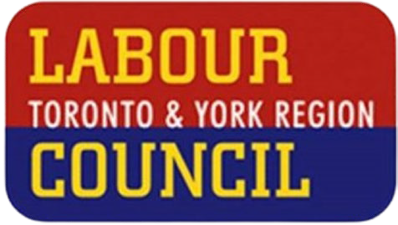LABOUR DAY SAMPLE OP-ED

A Canada for Workers: Made Here; Paid Here

## *Date*

## *By (union leader)*

This Labour Day, as we gather in Toronto and York Region for parades, picnics, and celebrations, let’s not forget what we’re really marking: the history and power of workers. Workers power this country and we deserve to be acknowledged for it. That’s why this year’s Labour Day Parade theme is **A Canada for Workers: Made Here, Paid Here**.

For too many, the past few years have brought more uncertainty than celebration. A worsening housing crisis, rising costs, and insecure jobs are making life harder for working families. While big corporations post record profits and raise prices, our public services are under attack, and governments are failing to act. In communities across the country, workers are doing everything right yet still falling behind.

That’s why now, more than ever, we need a powerful, united movement of workers standing together in our unions. Because when workers come together, we deliver real results.

(If you want to include a short story relating to your own community – job losses, union victory, struggles with access to health care, housing or anything else – you can do that in 2-3 lines here)

While politicians offer empty promises and CEOs chase profit at any cost, Canada's unions are delivering real results. Together, we've secured national wins that benefit all workers: national dental care, a path to Pharmacare, and $10-a-day child care. At the municipal level we supported candidates that support workers by delivering better funding for services (instead of cuts), and policies that are improving housing, transit and jobs.

When we organize, we don't just win better contracts and safer workplaces – we raise the bar for everyone.

It’s time for a different kind of common sense—one that’s rooted in solidarity and focused on the common good. It’s common sense to fight for living wages, affordable housing, and strong public services. It’s common sense to demand that the people who build our communities, care for our loved ones, and keep our economy going, are treated with the dignity and respect they deserve.

At a time when Trump’s trade war is destabilizing global supply chains and putting Canadian jobs at risk, we can’t afford to sit on the sidelines. Labour unions have been at the forefront of the “Made in Canada” movement – seeking to change public procurement policies to favour Canadian-made goods to help offset the impact of U.S. tariffs on Canadian goods. Too many politicians claim to stand with us, then cut public services, ignore the housing crisis, pour money into the military and hand out tax breaks to the wealthy. But we won’t let them get away with it.

As a [*Labour Council, Union, Community organization]* we promise to keep organizing, bargaining, and pushing every level of government until we get the respect and acknowledgement we deserve.

We’re not going to go back to the days when workers were disposable, and the rich got all the breaks. We’ve seen what that looks like, and we won’t stand for it. We march on Labour Day to remind the bosses that we are here, we shape our own future, and we are never going back. The future belongs to those of us who believe in fairness, justice, and equality for all. And together, we’re going to build that future—one that works for everyone, not just the wealthy few.

This Labour Day, we're sending a clear message: when workers stand together, we don't just make Canada strong – we deliver progress for everyone. We also deserve to benefit from that progress – that’s why we need is **A Canada for Workers: Made Here, Paid Here**.

That's what we celebrate, and that's what drives us forward.

*(Union leader) is (title) of (organization).*

